Homes of Integrity Construction Inc
518 Edsel Dr Richmond Hill, GA 31324
₍₉₁₂₎₋₇₂₇₋₂₉₂₀
_{cel (912)-596-0643}

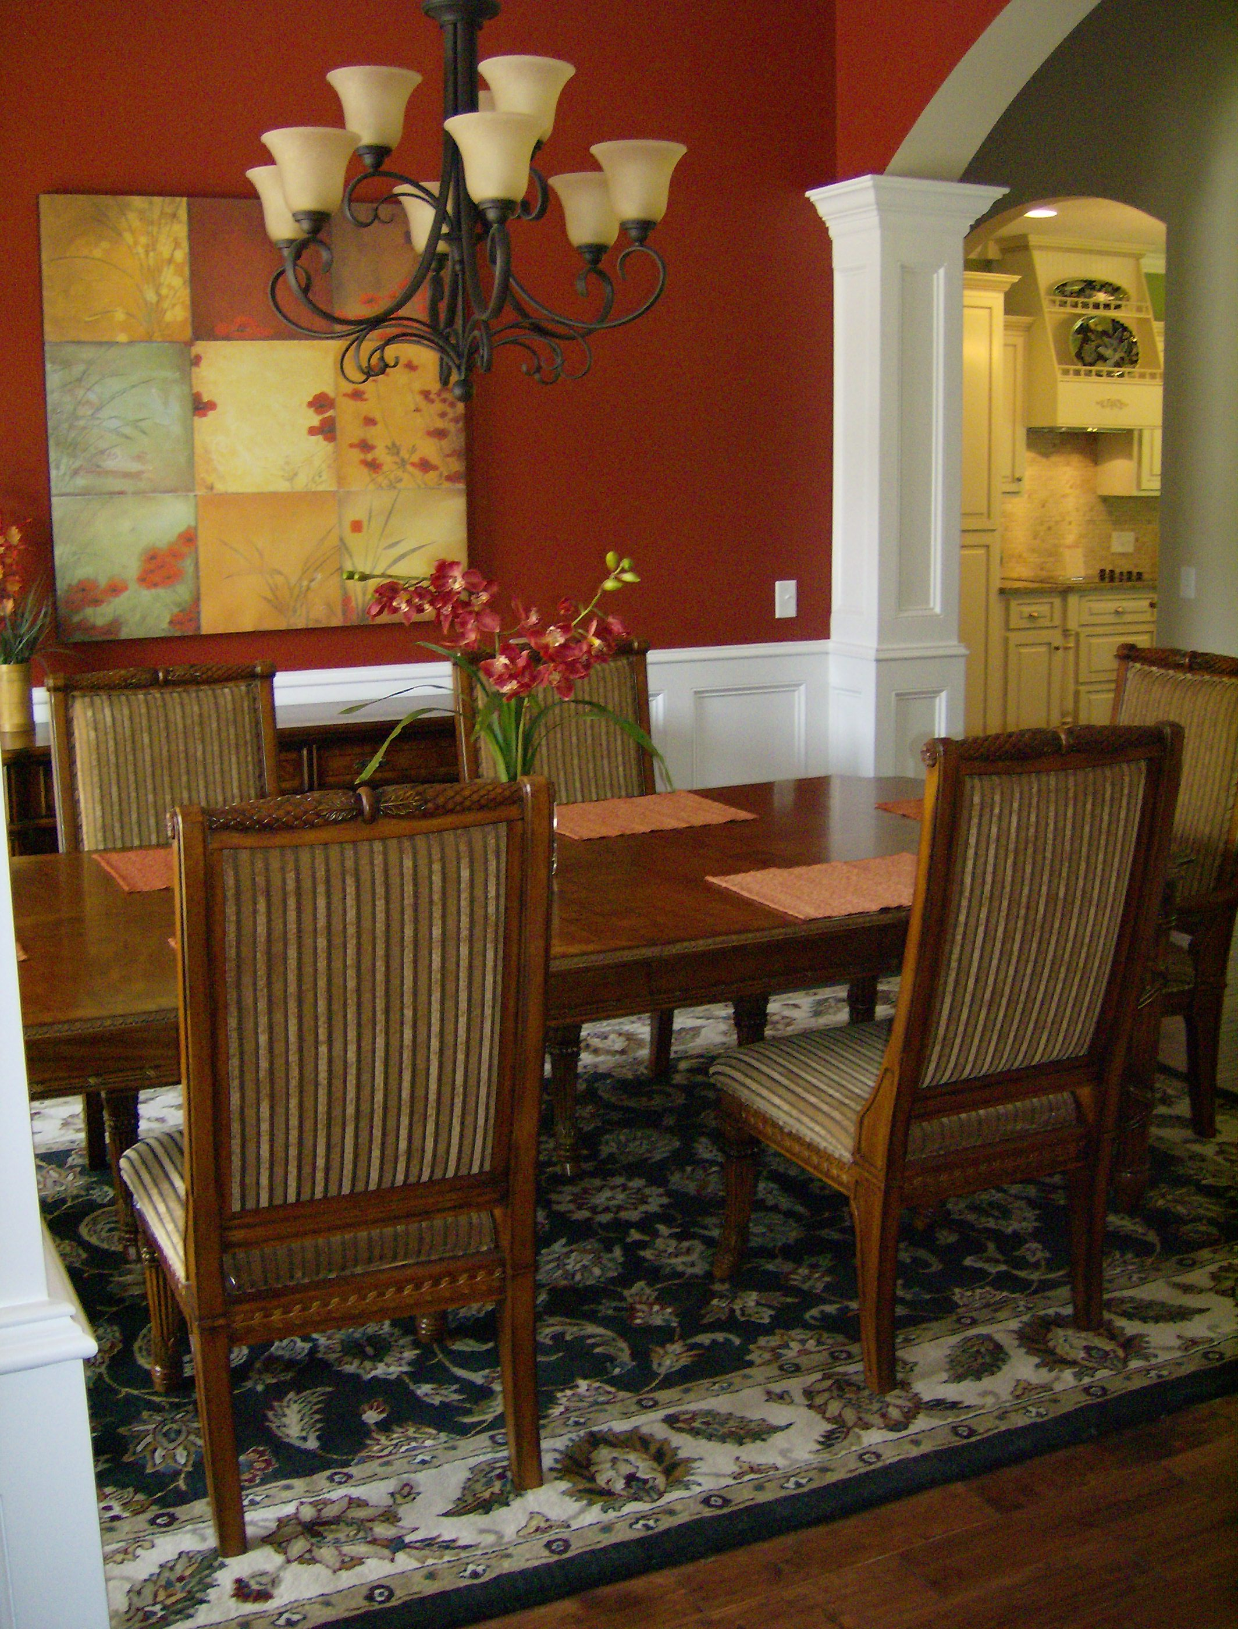

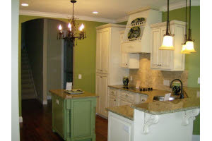

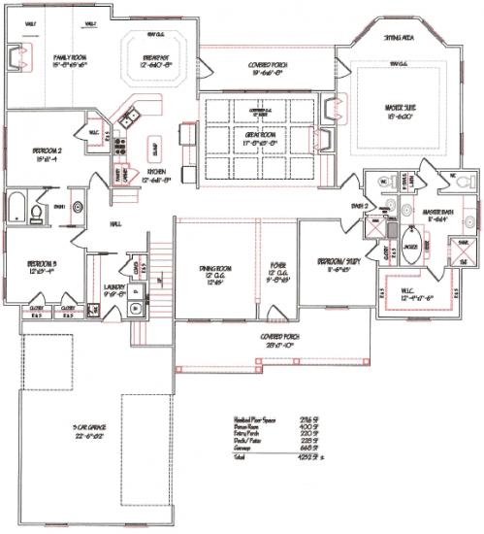

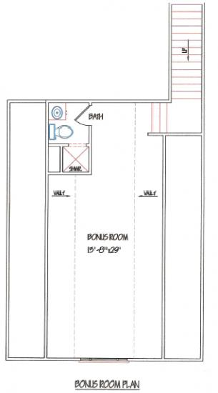

25 St. Catherine Cr.
The Bluffs,
Richmond Hill
$499,900.00
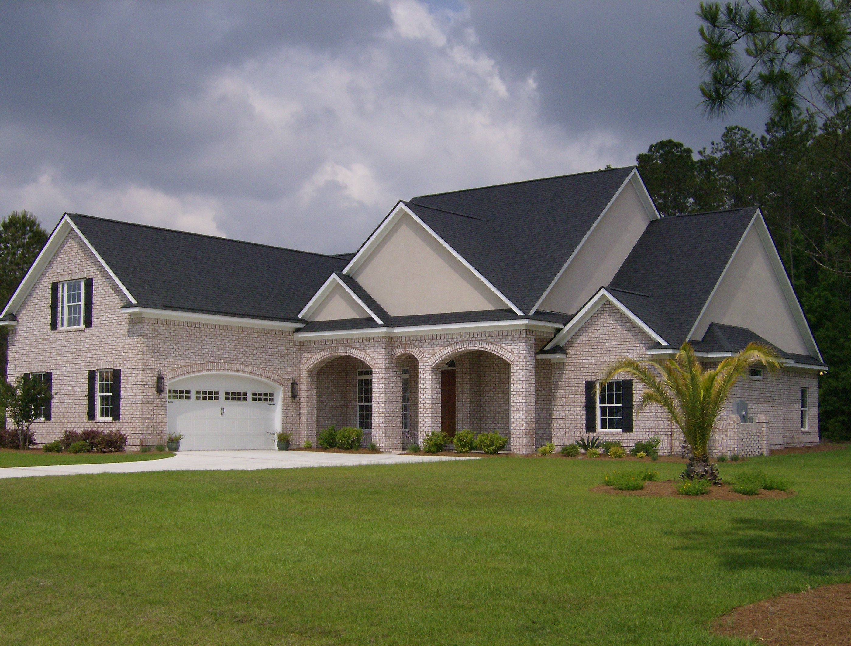

*Style: Traditional with stucco and brick exterior
* 4 bedrooms and 4 bathrooms
*Automatic 3 carriage house garage doors
*Sprinkle system already installed
*Great room and family room have TV already installed over the fire places
* 3 fireplaces in the house total
*Bonus room and a keeping room
*A gourmet kitchen with a separate cook top
*Granite counter tops in the kitchen
*Solid hardwood and travertine flooring
*Home theater in the bonus room complete with a state-of-the-art sound system with hidden speakers, a projector, and a projector screen
*A wet bar is also located in the bonus/theater room as well

Great family neighborhood!!!
Call Meagan Mowry for a showing today!
912-596-0643

