Homes of Integrity Construction Inc
518 Edsel Dr Richmond Hill, GA 31324
₍₉₁₂₎₋₇₂₇₋₂₉₂₀
_{cel (912)-596-0643}
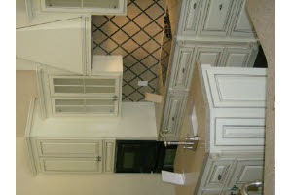

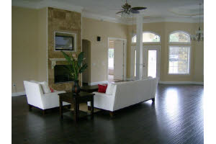

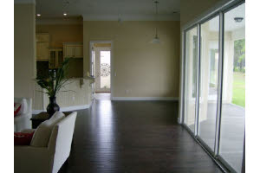

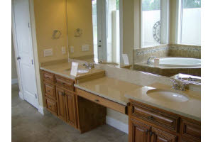

322 St. Catherines Circle
The Bluffs,
Richmond Hill
$539,900.00
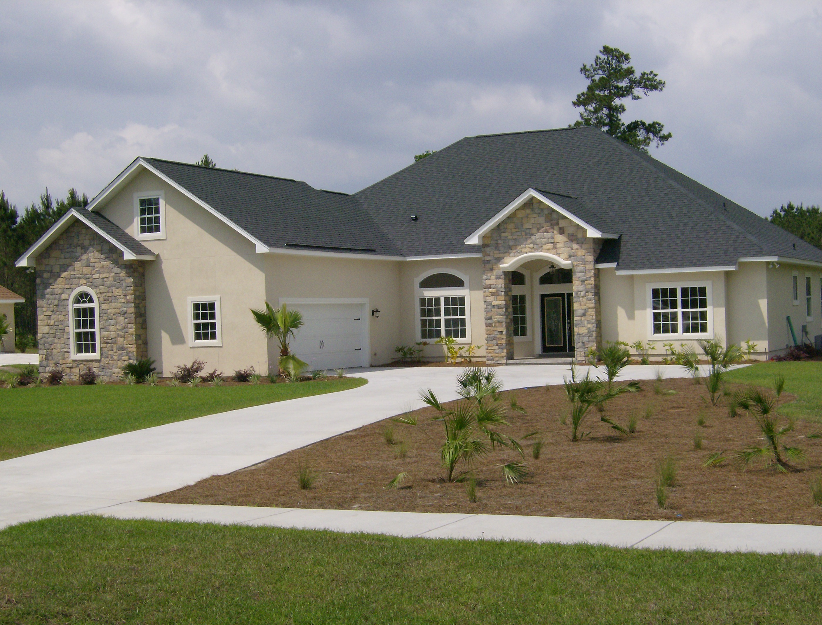

* This spacious Mediterranean home built in 2008 includes:
* 4 Bedrooms, 4 total/full baths plus large bonus
*12 foot ceilings in living areas
*Jetted/whirlpool tub in master bathroom
*Cook top range in kitchen, dishwasher, and microwave, built-in-wall oven
*Hardwood floors
*Lakefront property
*Master bath overlooks garden/atrium and lake view
*Separate laundry room
*Large covered back porch
*Sprinkler system
*Automatic 2 car garage with garage door openers
*Intercom system
*Breakfast area separate from dinning room
*Community park, pool, tennis courts, and recreation facilities

Great family neighborhood!!!
Call Meagan Mowry for a showing today!
912-596-0643

